Trow, Cameron

Notanemail@notawebsite

Abstract

[Draw your reader in with an engaging abstract. It is typically a short summary of the document.   
When you’re ready to add your content, just click here and start typing.]

ASCII GAME

DESIGN, DEVELOPMENT AND TEST APPLICATION TO SPECIFICATION

ASSessment1/1 DESign, DEVelopment AND TEST APPlication TO SPECification

Table of Contents

Design 2

Noun/Noun Phrases 2

UML Diagram 3

Testing 3

Menu 3

Game 3

End of Game 3

Sound 3

Color 4

Paddle change size 4

demo 4

health 4

score 4

controls 4

pause Menu 4

Exit game esc shortcut 4

Multiple control schemes 4

Additional Features 5

Sound 5

Change size 5

Color 6

Demo mode 8

Pause menu 8

# Design

|  |  |  |
| --- | --- | --- |
| Noun/Noun Phrases | Strong enough | why |
| Breakout | n/a | System Scope |
| Ball | Yes | Complex Object |
| Score | No |  |
| Brick | Yes | Complex Object |
|  |  |  |
|  |  |  |
|  |  |  |
|  |  |  |
|  |  |  |

## UML Diagram

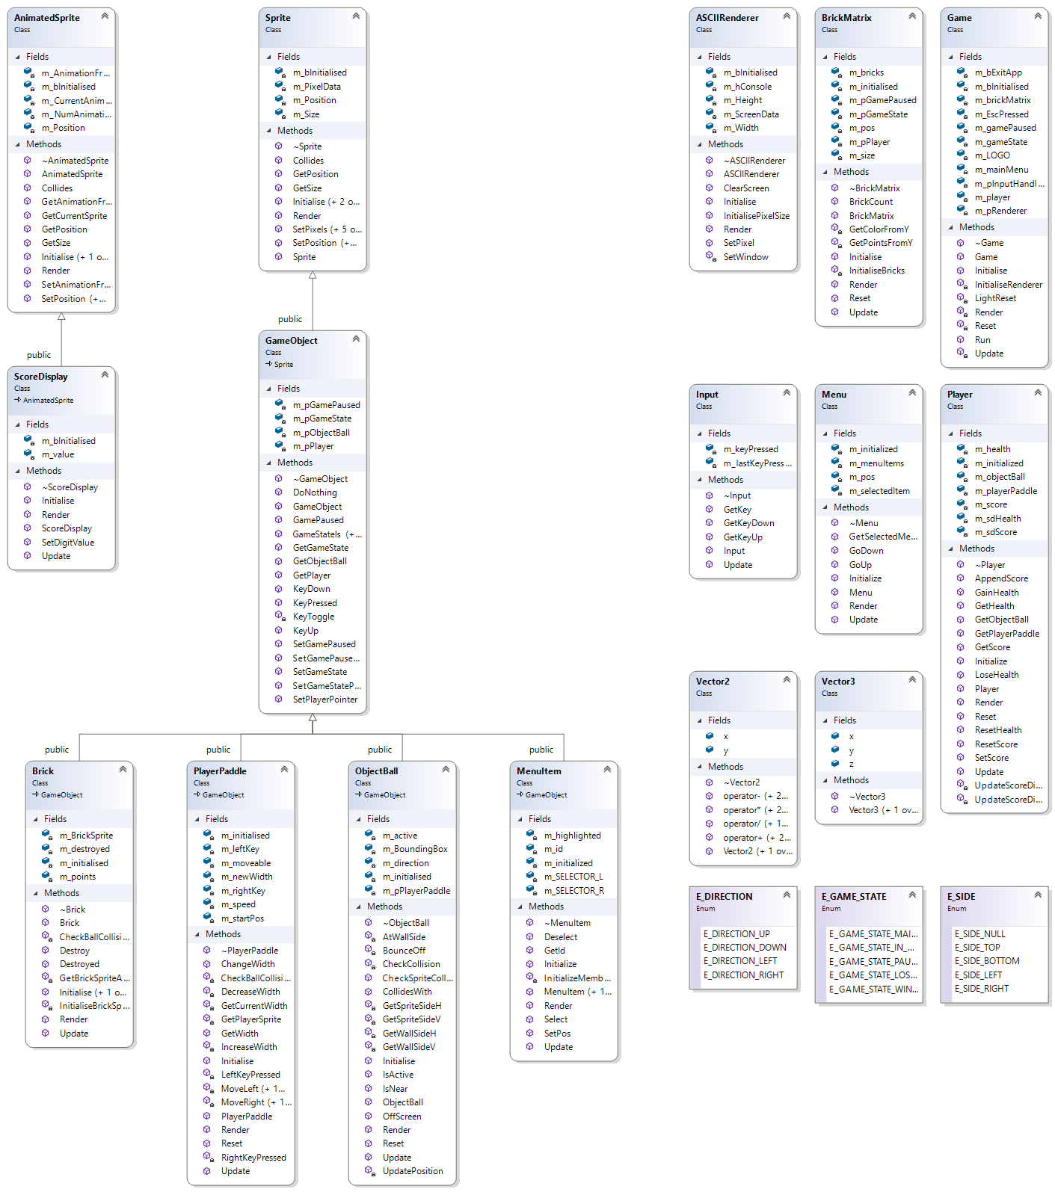

# Testing

|  |  |  |  |  |  |  |  |
| --- | --- | --- | --- | --- | --- | --- | --- |
| Test numb | Location / object | Input | Purpose | Expected output | Comment / verified | Evidence location | |
| 1 | Menu | W,s | Change selected item | ‘[…]’ move | yes |  |
| 2 | Game | ??? | ??? | ??? | ??? |  |
| 3 | End of Game |  | Changes state to E_GAME_STATE_LOSE_GAME | BOO appears on the screen | yes |  |
| 4 | Sound |  | Play sound | Sound is played when ball hits wall | yes | n/a |
| 5 | Color |  | Bricks are evenly distributed a color to be | Colorful bricks | yes | Most screenshots |
| 6 | Paddle change size |  | Paddle shrinks on health loss | Paddle changes size on death | yes |  |
| 7 | Demo |  | Changes game to demo mode | Wait a long time and demo shows | yes |  |
| 8 | Health |  | Heath goes down on ball fall out of game | Health goes gown | yes |  |
| 9 | Score |  | Detects for ball hitting a brick | Score goes up by amount specified by color of brick | yes |  |
| 10 | controls | A, D | Moves the paddle | The paddle moves | yes |  |
| 11 | pause Menu | ESC (in Game) | Changes state to pause game | The word pause appears on the screen | yes |  |
| 12 | Exit game esc shortcut | Double press escape on main menu | Closes game | Closes game | yes |  |
| 13 | Multiple control schemes | A, D or left, right  main menu only: enter or space | Detects for either key | Depends on the key | yes |  |
| 14 |  |  |  |  |  |  |
| 15 |  |  |  |  |  |  |
| 16 |  |  |  |  |  |  |
| 17 |  |  |  |  |  |  |
| 18 |  |  |  |  |  |  |

# Additional Features

## Sound

Makes sound when ball hits wall

Easter egg: if the ball bounces off these sides in odder you will hear the 4 main notes of lavender town: bottom, right, top, left

In Object Ball::Bounce Off

Lines 202,208,215,222

## Change size

The paddle can change size though out the game depending on the health

Location: PlayerPaddle.cpp (169-187), (156)

## Color

## 

The bricks are different colors depending on point value

|  |  |  |  |
| --- | --- | --- | --- |
| Brick | Color | Color name | Points |
|  |  | Blue | 10 |
|  |  | Green | 20 |
|  |  | Yellow | 70 |
|  |  | Red | 100 |

Brick Matrix.cpp

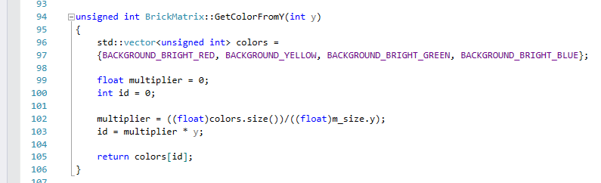

## Demo mode

## 

This was just used for testing but now appears when you wait on the main menu

Locations:

* PlayerPaddle.cpp:17, 54-61, 85-92,145-148
* ObjectBall.cpp:56-62
* Game.cpp:14, 31,142-153,244-249,268-271,281-288,293-302,412,421-424

## Pause menu

Added a pause menu for when you press escape, double pressing escape will bring you to the main menu

Location:

* Game.cpp:115-140,306,318,323,349-366,427-431